Reward!!!
Missing dog
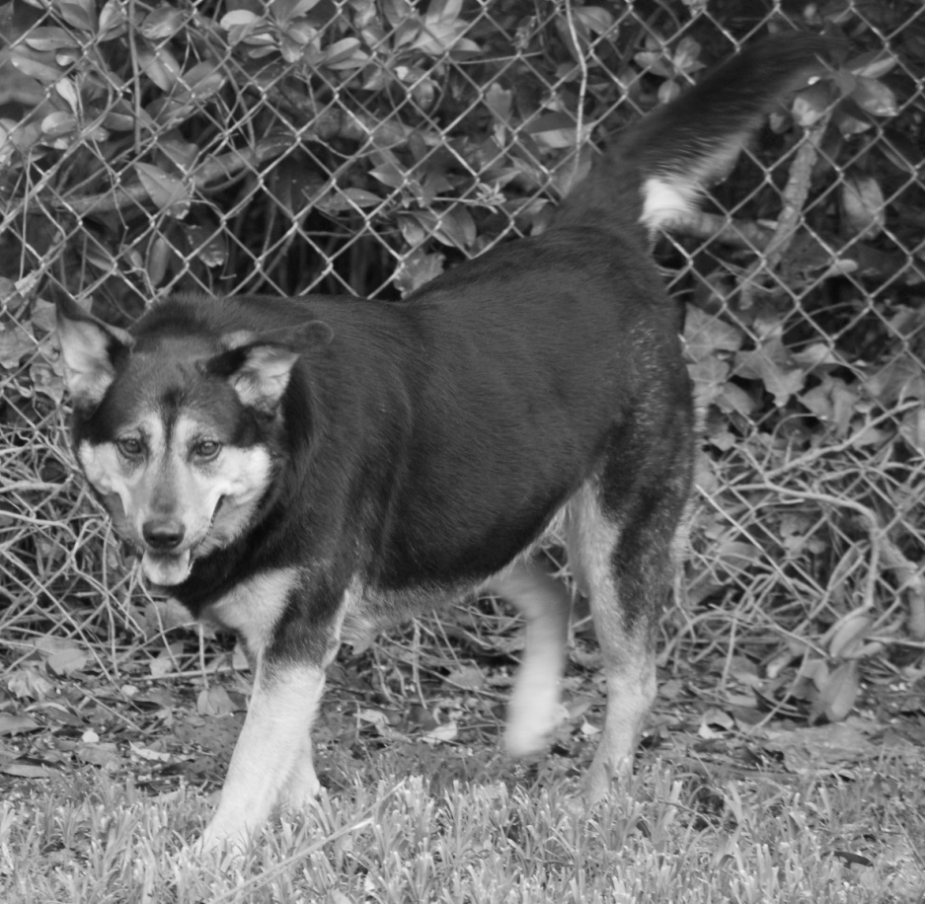
Lost in the leeds area on 5/24. Sasha is black and tan with a spotted tongue, about 70lbs and may be shy or nervous around people. She pulled out of her collar so she has no identification.
SHE IS NOT VICIOUS!
Please call 205-516-9825 or 205-542-6447 anytime day or night if you have seen her.

